Christos Lionis MD PhD FRCGP(Hon) FESC FWONCA

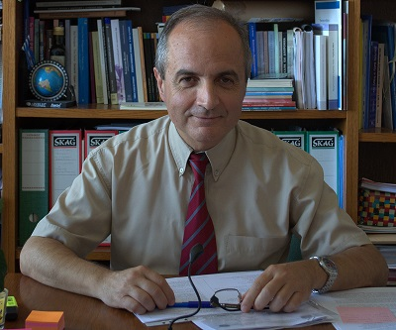
Christos Lionis is a medical doctor and Professor with a strong interest in primary care and public health education, practice, and research. Christos has served the Clinic of Social and Family Medicine (CSFM) at the School of Medicine, University of Crete (http://www.fammed.uoc.gr/Joomla/) since 1995 (March) initially as an Assistant Professor and in 2009 as a Professor of General Practice and Primary Health Care and CFSM Director. He is also appointed as Guest Professor of General Practice in the Institute of Health and Medicine at the University of Linkoping, Sweden (2018), a position that he continues to hold today.

With a strong orientation in research and education, Christos has been actively involved in the development of Primary Care and General Practice in Greece and internationally. As part of his work with the CFSM, Christos has been involved both as PI and collaborator in multiple large European and international research collaboratives and research proposals funded by the EU and international agencies. His work has focused on capacity building of primary health care and public health in Greece and he is widely consulted on issues related to primary care and public health in Greece and internationally. Christos has a passion for education and has a played a key role in the development medical training, continuing medical education, and quality standards in primary care and public health nationally. He has developed a strong collaboration with WHO especially during the past two years. Christos is also involved in an editorial and advisory capacity with a number of international journals. He also is a member of the Executive Board of various professional organisations including that of WONCA Working Party on Mental Health where he is currently elected as Chair. He has been awarded as Honorary Fellow for the Royal College of General Practitioners (2009), the World Organization of National Colleges, Academies and Academic Associations of General Practitioners/Family Physicians (WONCA) (2016) and the European Society of Cardiology (2017). Christos has published 420 papers in international journals that they cited in PubMed. Since 2019, Christos is a member of the European Commission Expert Panel on Effective Ways of Investing in Health, while he has recently approved as a Member of the Scientific Advisory Group Vaccines of the European Medicines Agency.

