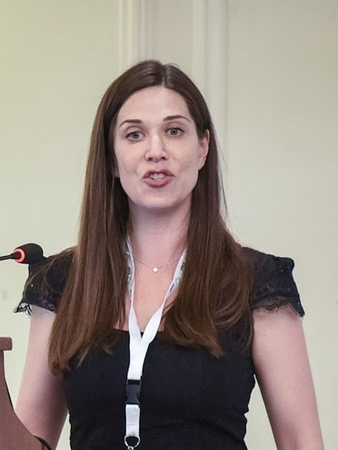
Sophia Papadakis Ph.D. MHA

Dr. Papadakis is a Research Scientist in the Clinic of Social and Family Medicine, School of Medicine at the University of Crete (Greece), and Affiliate Researcher in the Division of Prevention and Rehabilitation at the University of Ottawa Heart Institute, and Adjunct Professor, Faculty of Medicine, University of Ottawa (Canada). Dr. Papadakis is currently the Academic and Health System Consultant with the National Centre for Smoking Cessation and Training (NCSCT) in the United Kingdom.

Dr. Papadakis received her Ph.D. in 2011 from the Faculty of Public Health at the University of Waterloo and holds a Master’s in Health Administration (2004).

Dr. Papadakis area of interest is public health, health systems and disease prevention. Dr. Papadakis work is focussed on the design, delivery and evaluation of health behaviour change interventions in clinical and community settings with a particular focus on tobacco treatment. Dr Papadakis holds both experience and expertise in implementation science and the scale-up of evidence-based interventions and played a key leadership role in the scale-up of two internationally recognized best practice initiatives: the internationally recognized ‘Ottawa Model for Smoking Cessation’ and the ‘Champlain Cardiovascular Disease Prevention Network’. She has held multiple large research and knowledge translation grants and has been involved in development of several successful training programs for continuing medication education. has published more than 70 peer-reviewed papers and book chapters. She has been involved as co-editor or the European Tobacco treatment guidelines, and co-authored monographs and technical reports on this subject.

